Latihan modul 2 pertemuan 3

Nama:Rinaldi Adriyansah  
Nim: 51017017

1. 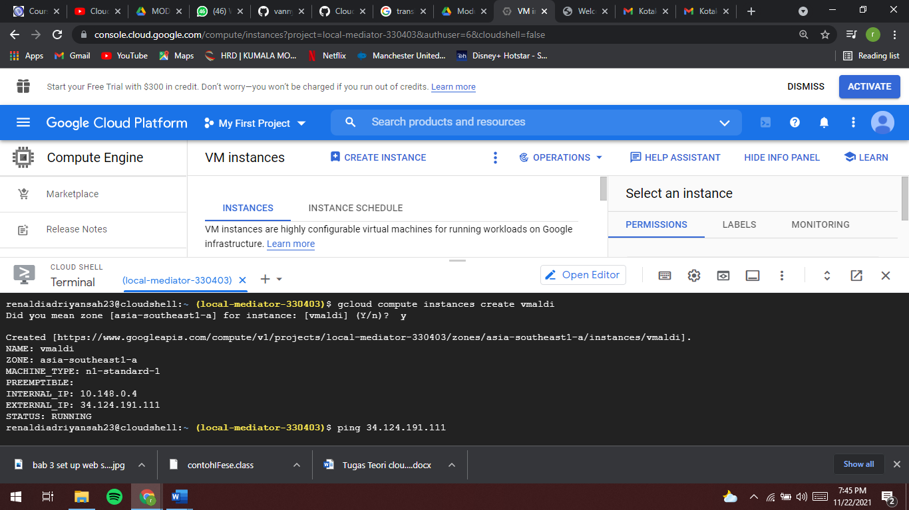latihan 1 Create VM Instance Using Cloud Shell

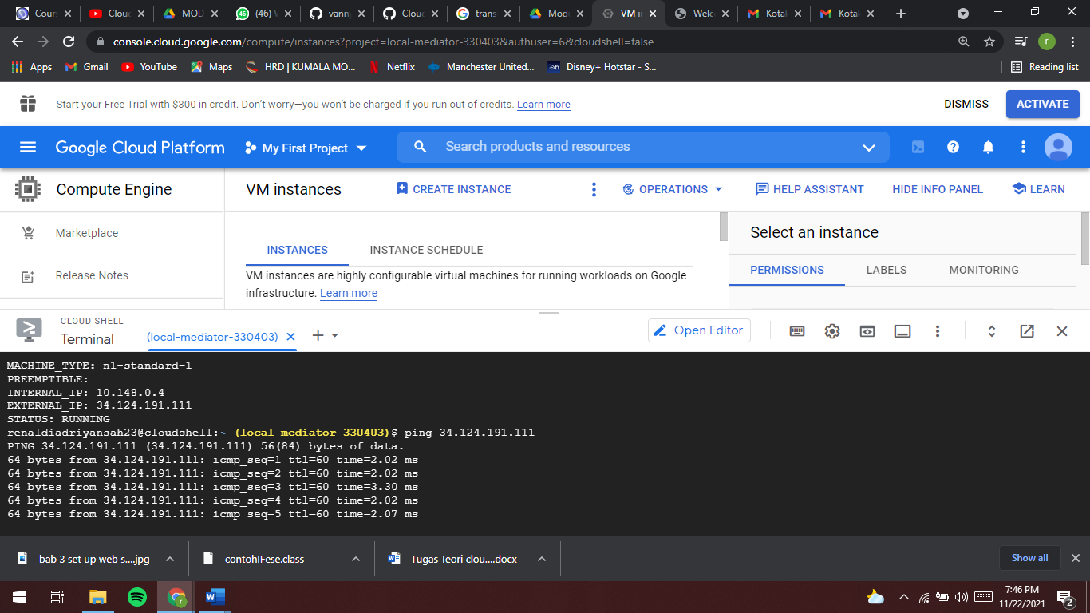

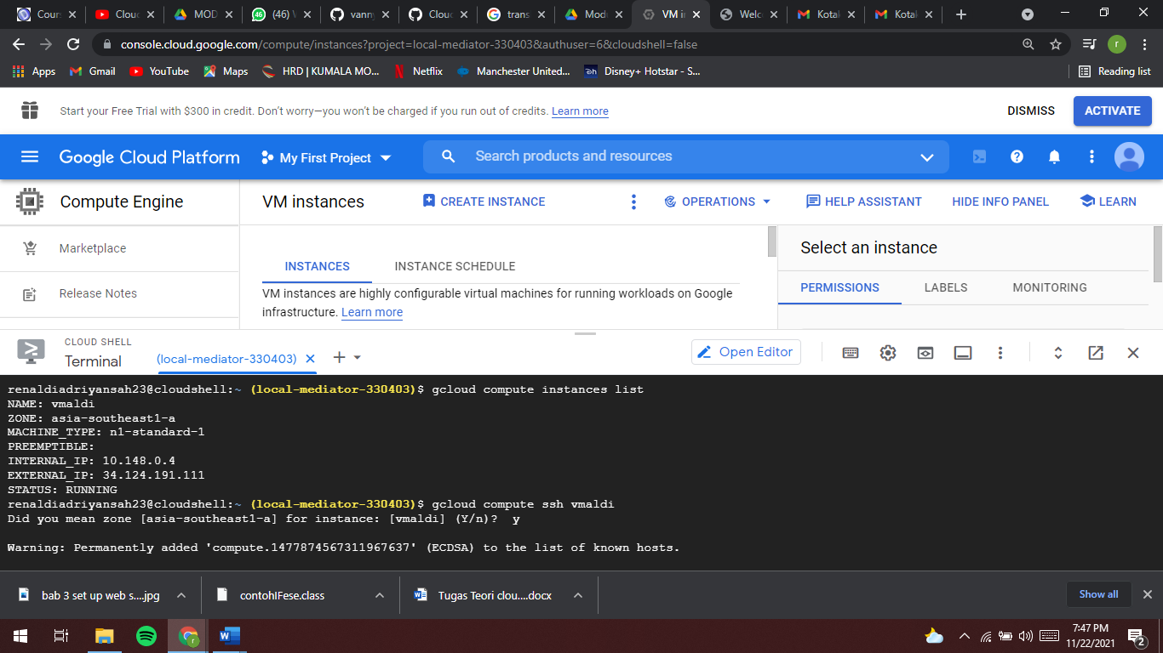

Lab 2

Create VM Instances Using Console

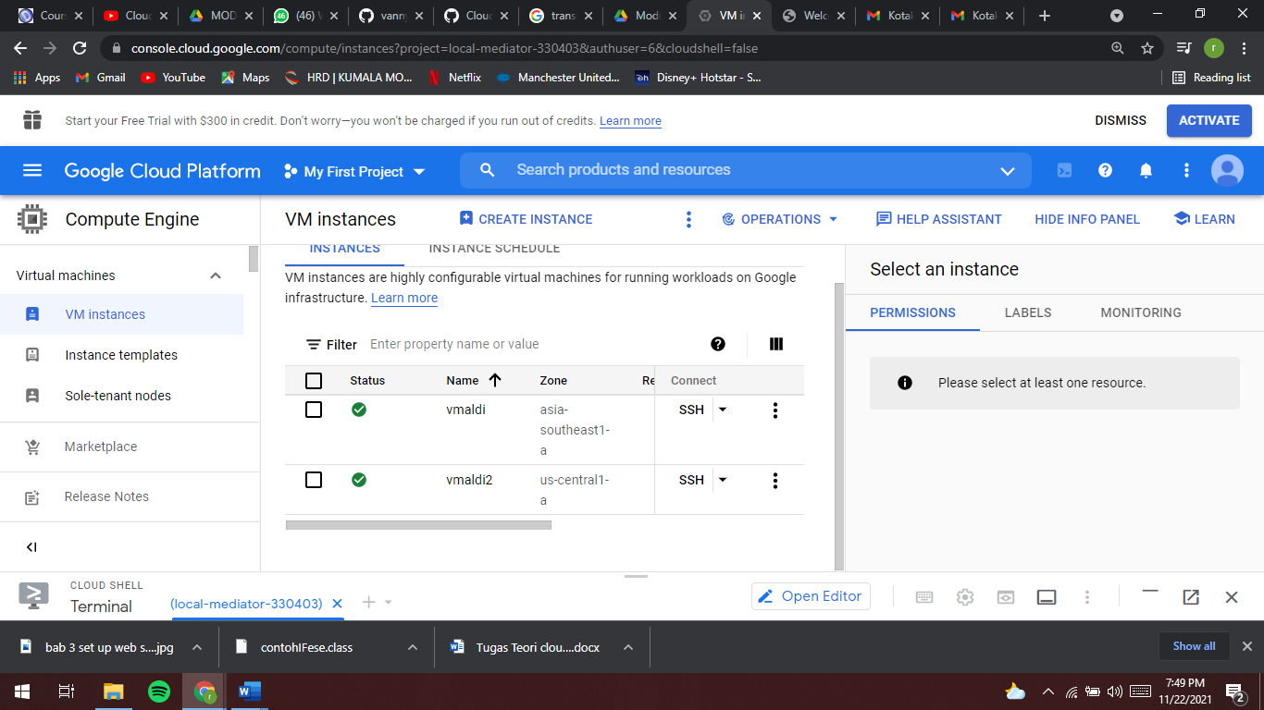

Lab 3 set up web server

